Guidance for Topic 2 DQ 2
- As always, don’t forget to enter your name in C2-D2.

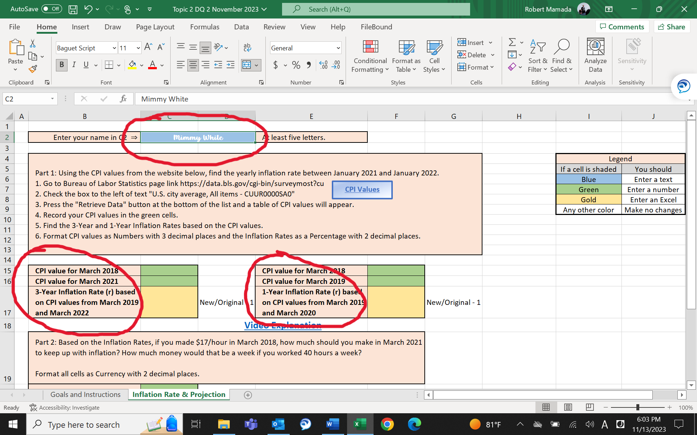

As you notice, the details of the questions appear once you enter your name.

- The next step is to click the link (CPI Values), and you will be guided to this web site. Click the top selection, and click “Retrieve Data.”

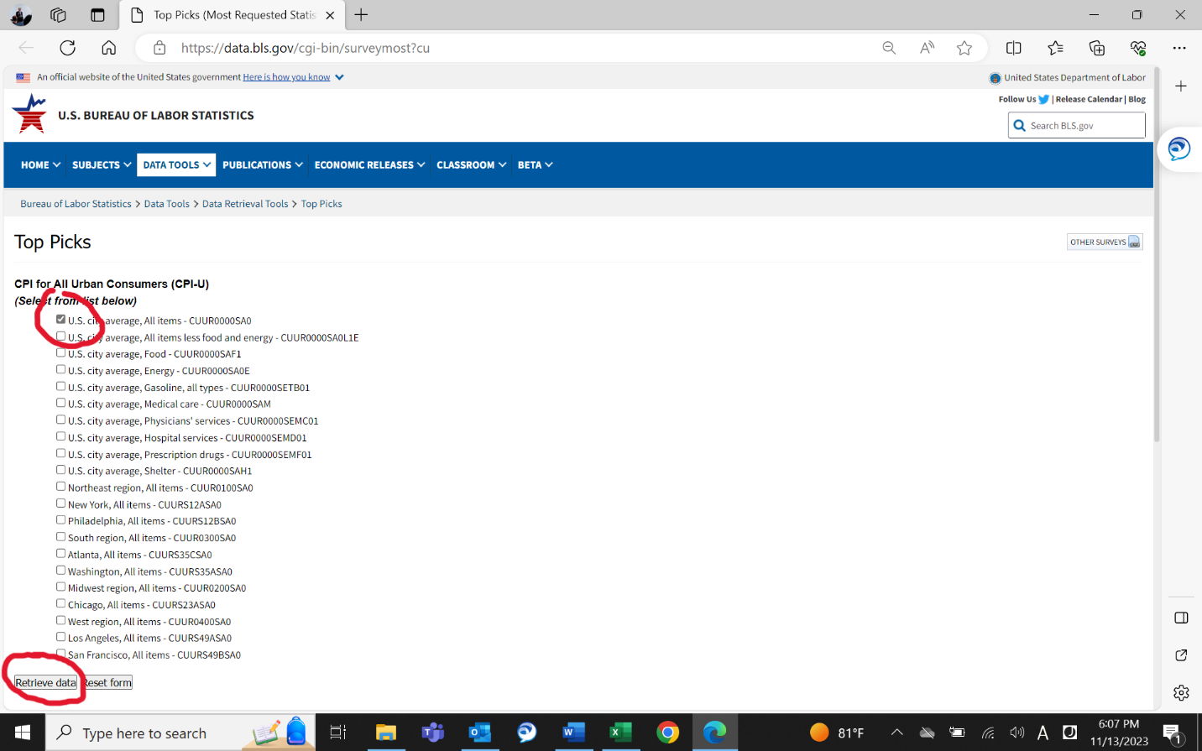

- You need to enter the numbers in C15 & C16 and F15 & F16. The numbers you need to enter are circled in red in the table. The pictures show the numbers to enter for C15 & C16.

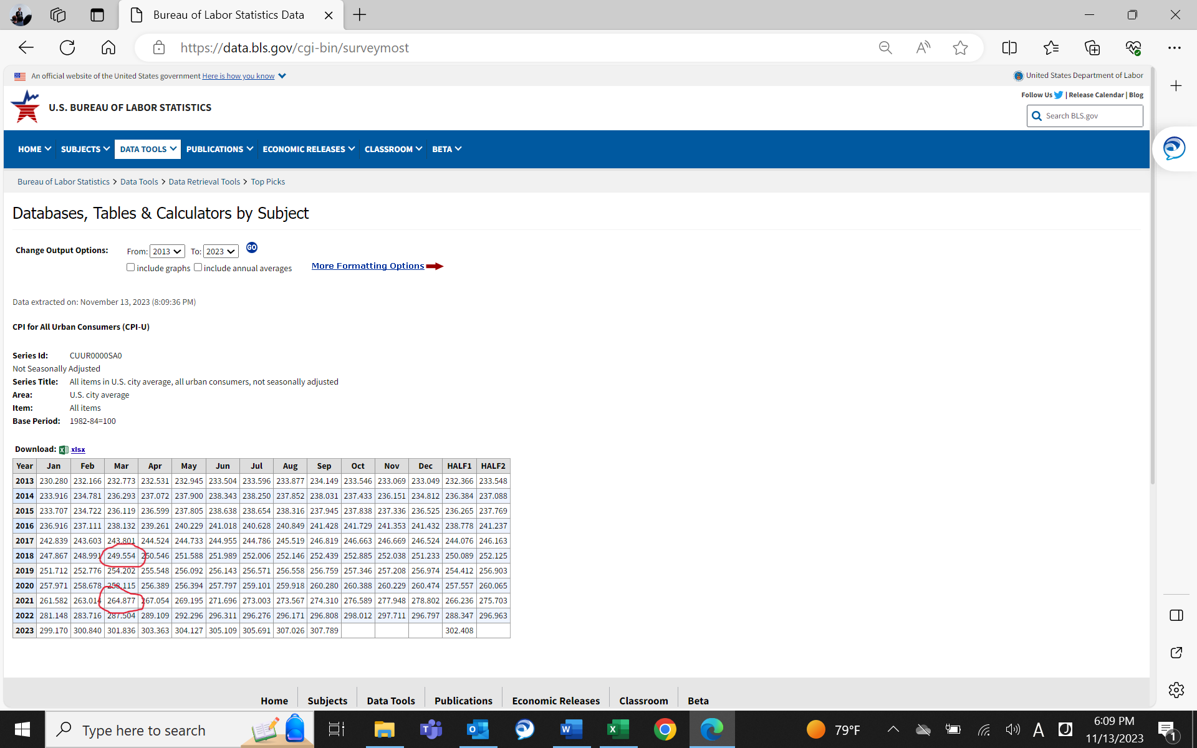

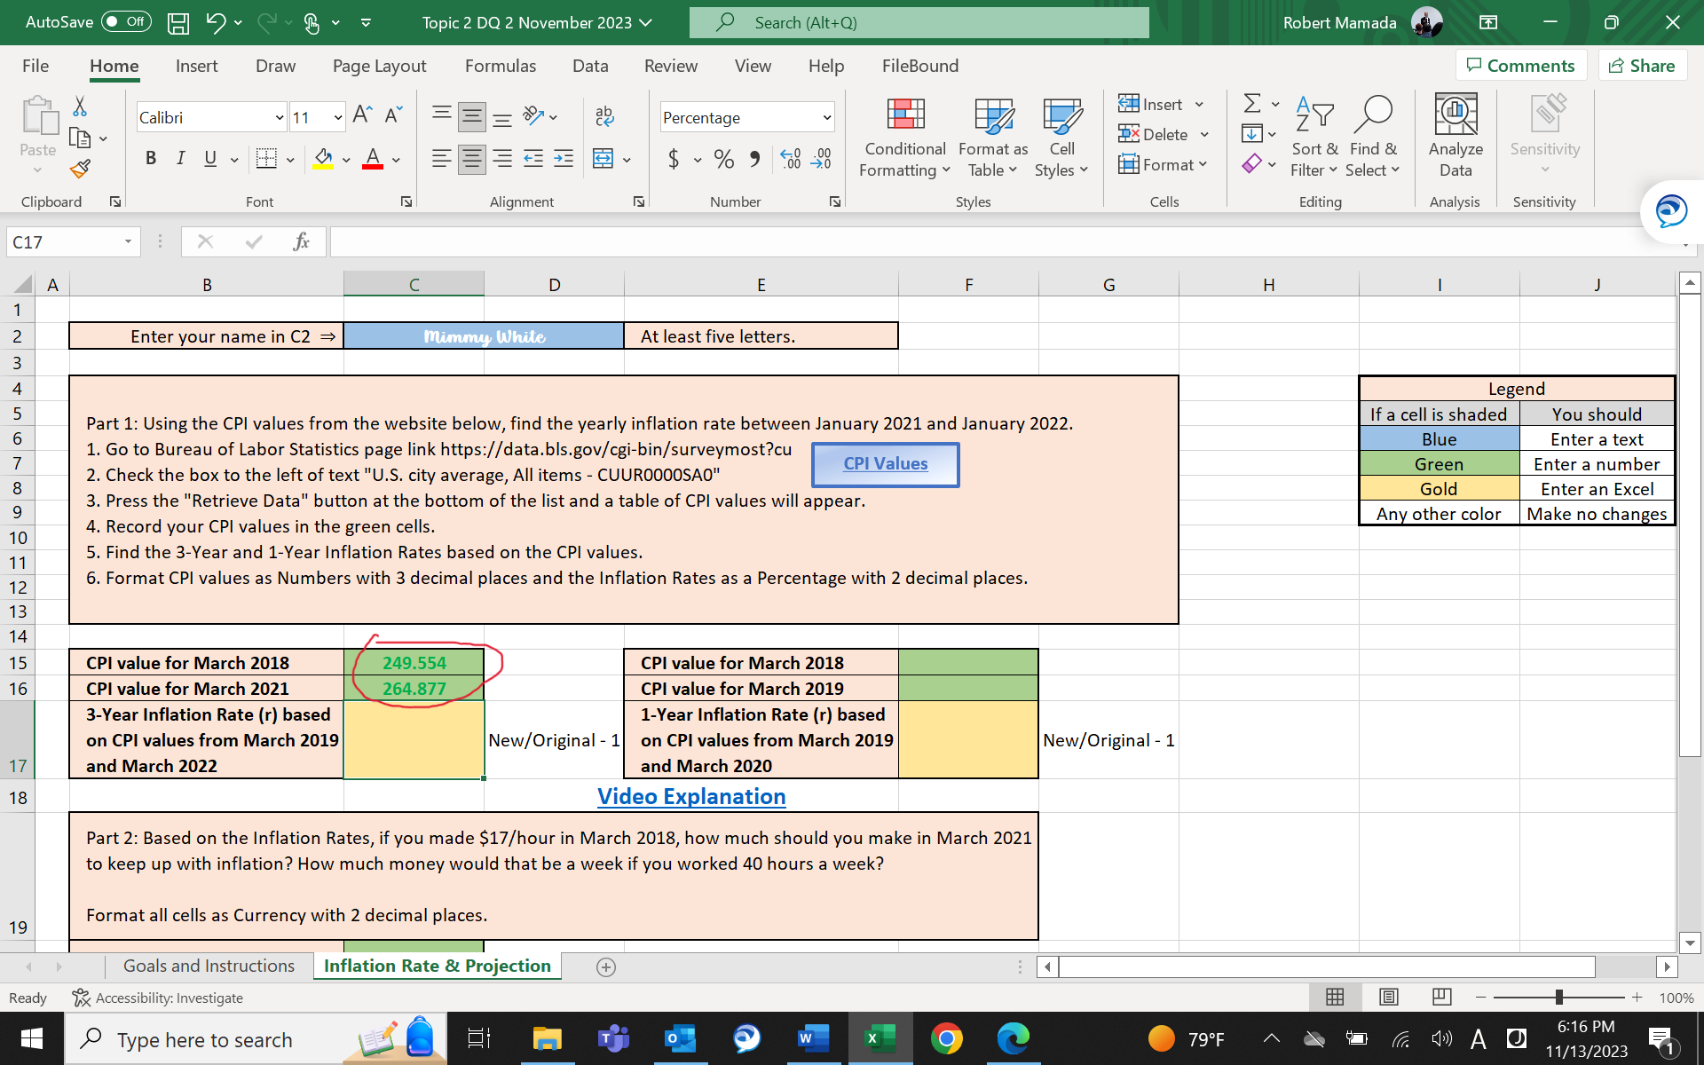

- Next, you need to enter a formula in C17 to find a three-year inflation rate. The formula is new / original – 1. In this case, “new” is C16, and “original” is C15.

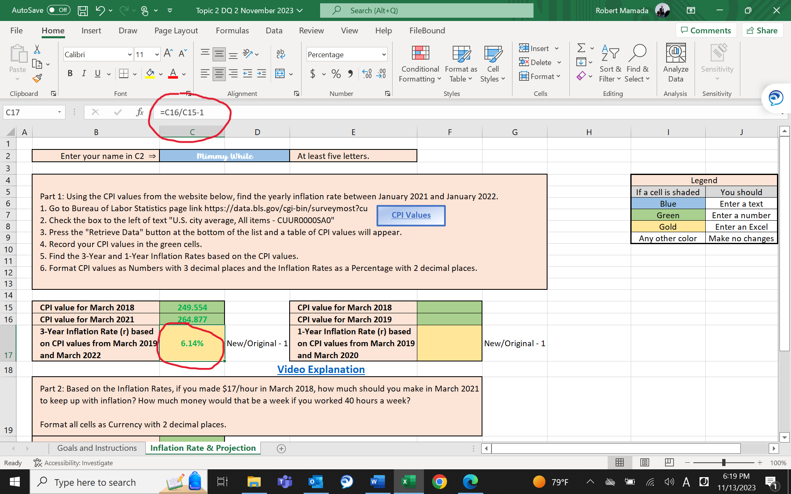

- Do the similar process for F15, F16 and F17.

- Next, we will do some analyses on your hypothetical wage rate. Enter the given wage rate in C20.

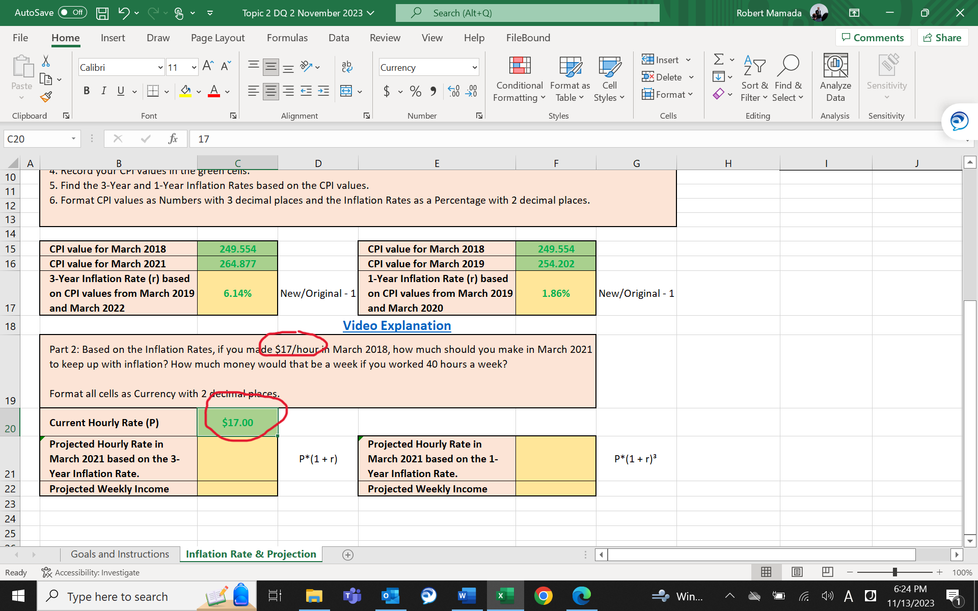

- Now, you need to enter a formula in C21. The formula you need to use is shown in D21. In this case, P is C20, and r is C17. So, the formula is =C20*(1+C17) which is shown in the picture below.

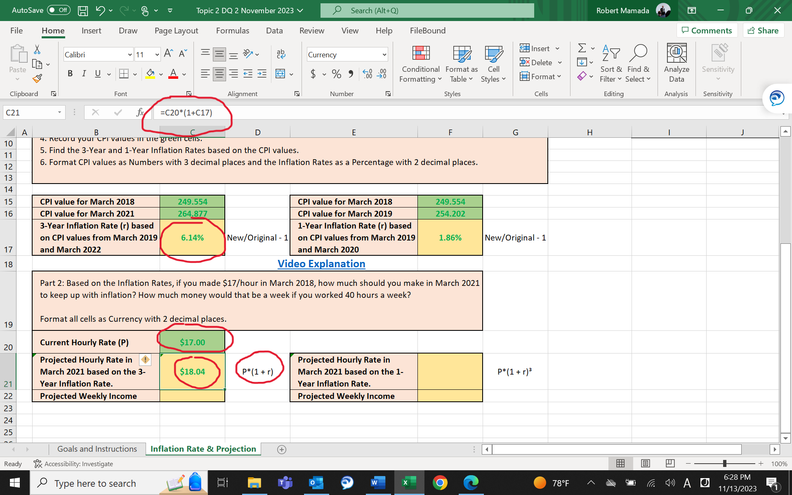

- In C22, you need to find your projected weekly income. Since you work 40 hours a week, and your projected wage rate is in C21, the formula you need to enter is =40*C21.

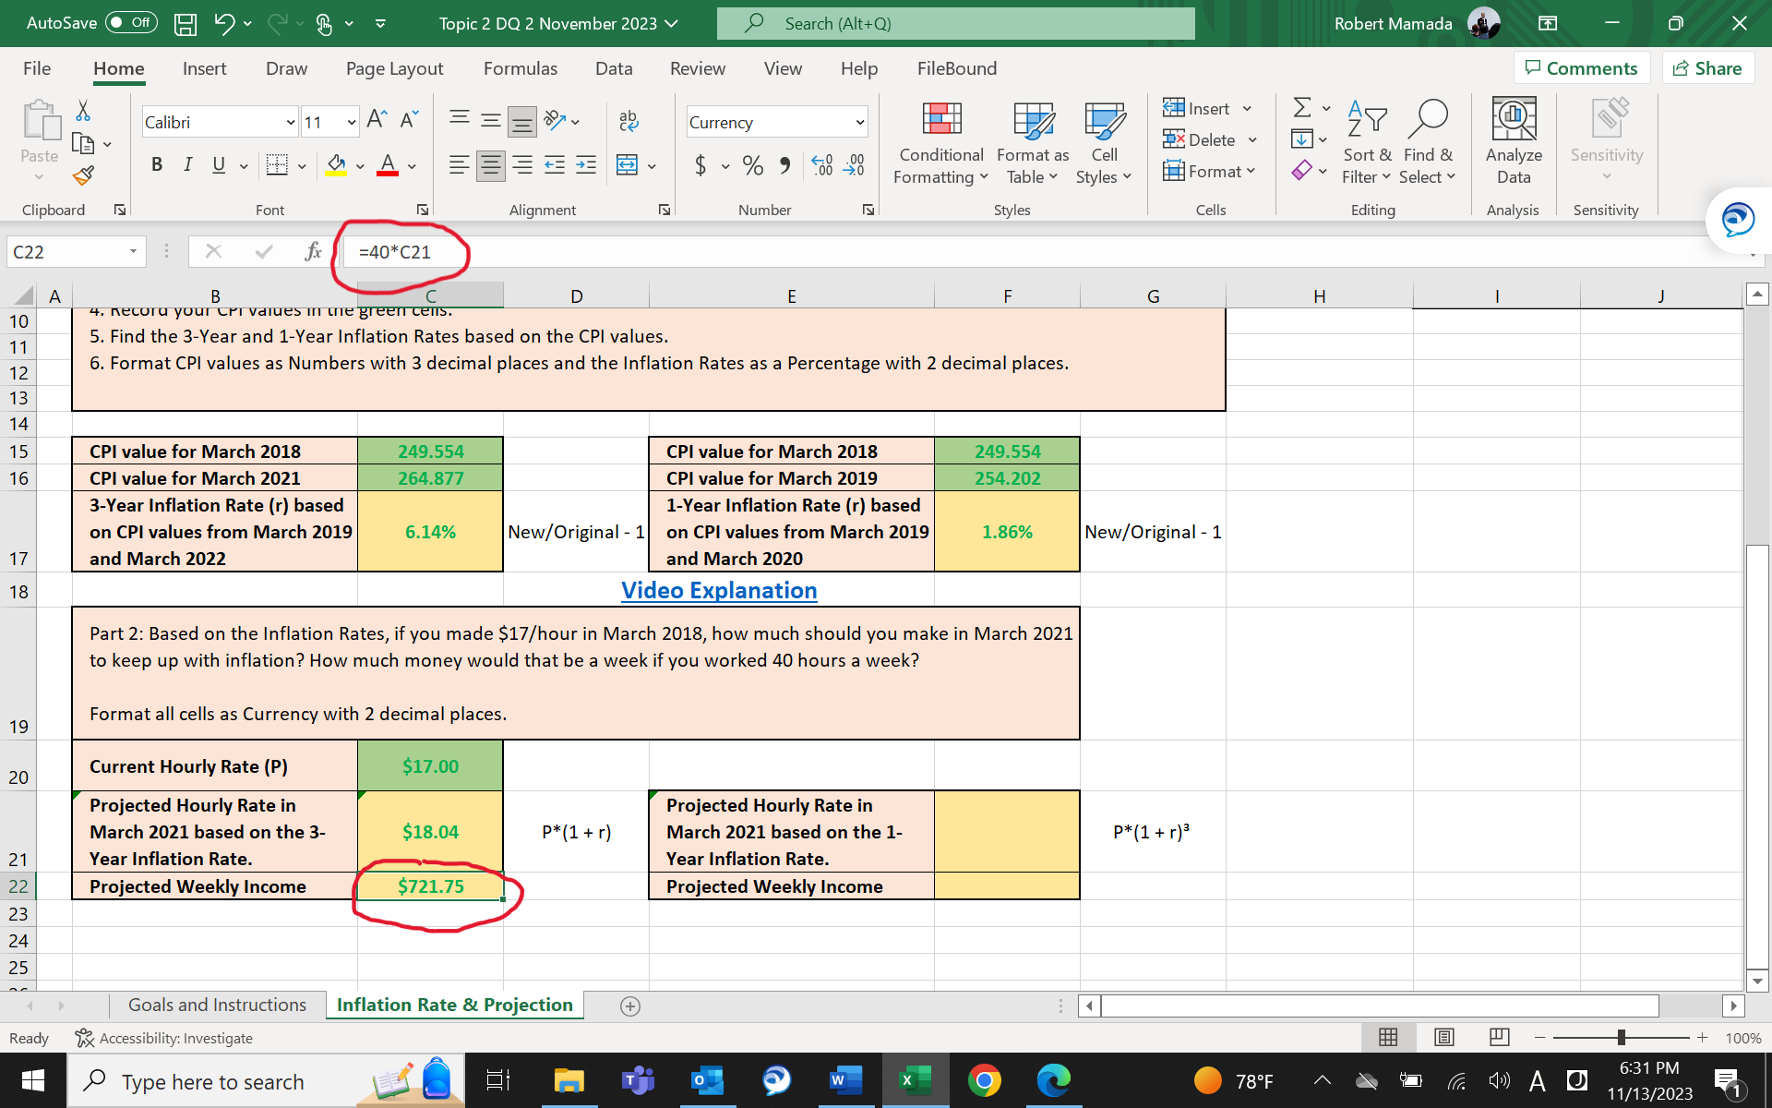

- Do the similar calculations for F21 and F22. But be careful. In F21, you need to calculate the three-year projection based on the one-year inflation rate you found in F17. So, the formula is now P*(1+r)^3 which is also shown in the picture below.

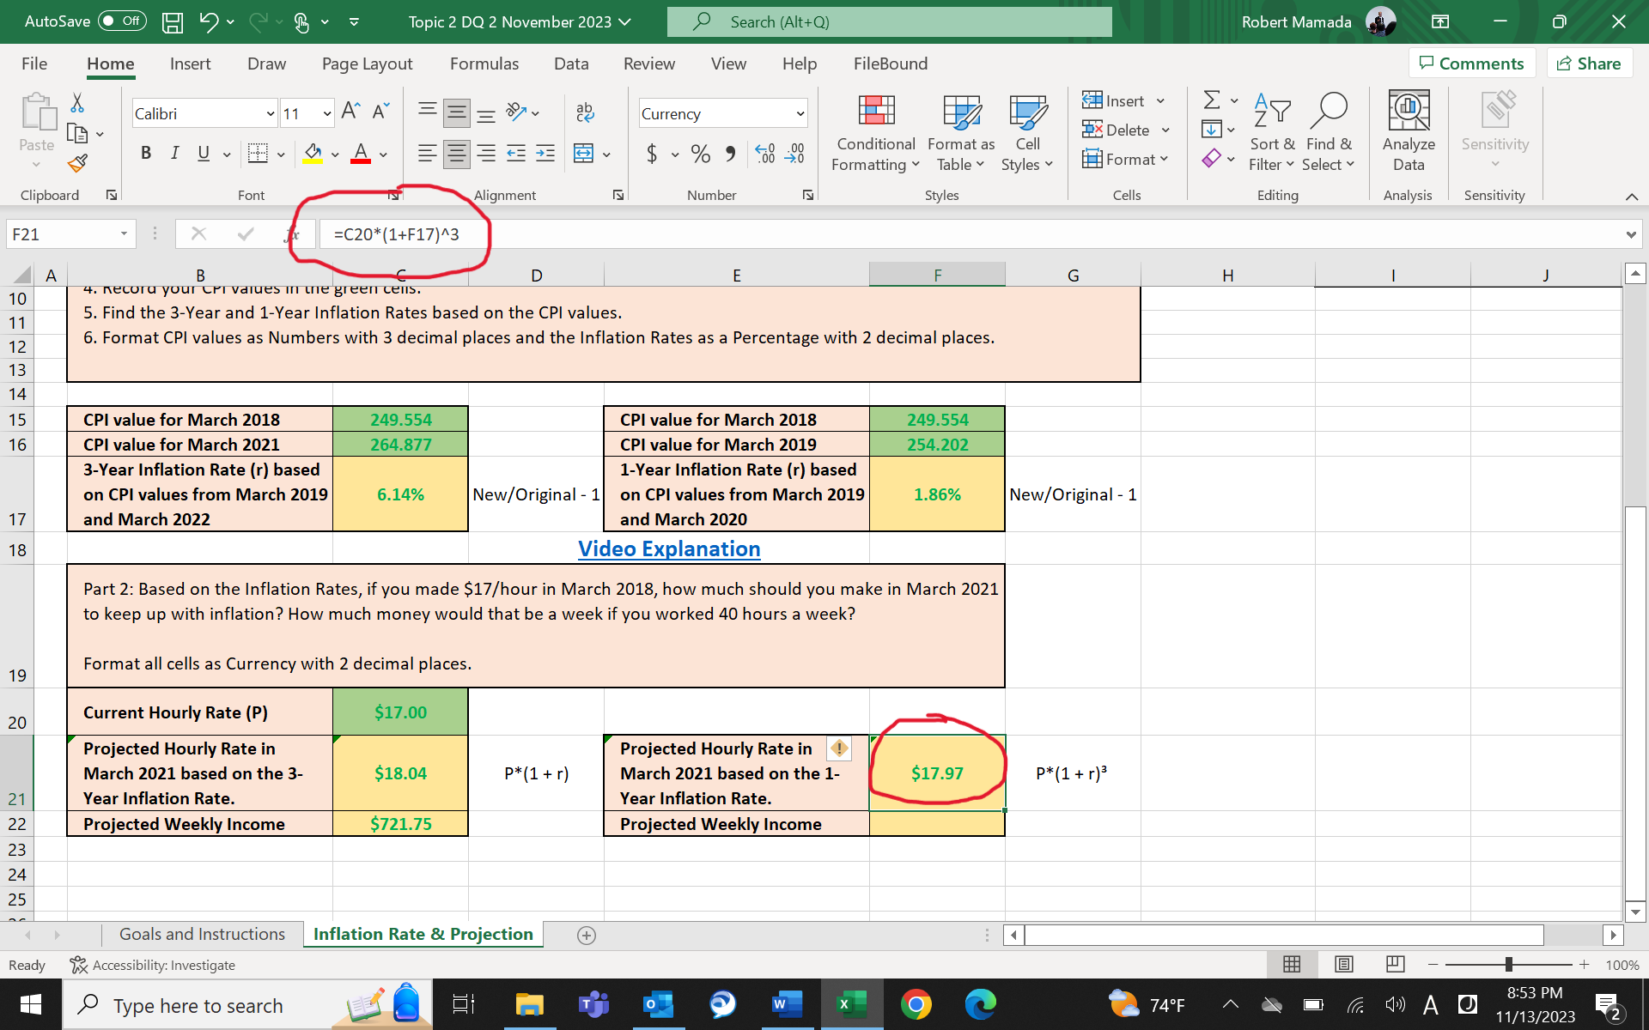

- The projected weekly income in F22 is similar to that of C22, which is =40*F21.

